1. Download Code as zipped file from IsaacStong/PUBG: Deployable WebApp for PUBG prediction model (github.com) and unzip to desired location.
2. Enter the computer search bar and open command prompt app (cmd) app. 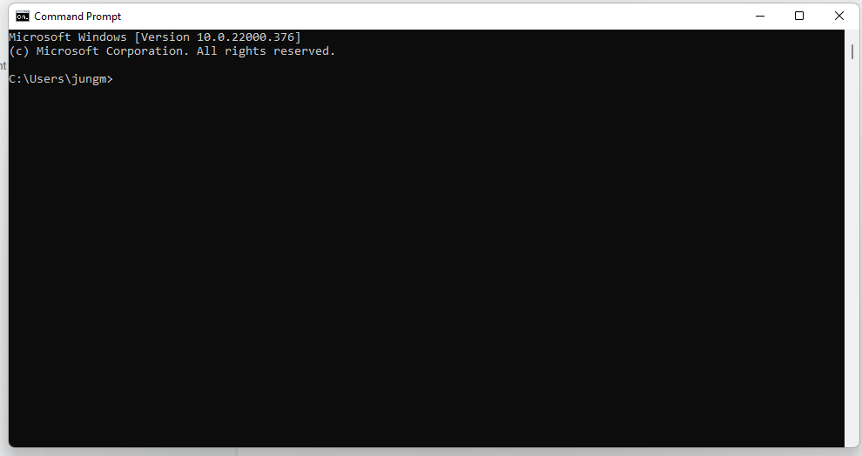
3. Using cd commands navigate to inside the PUBG folder where the manage.py file is located. 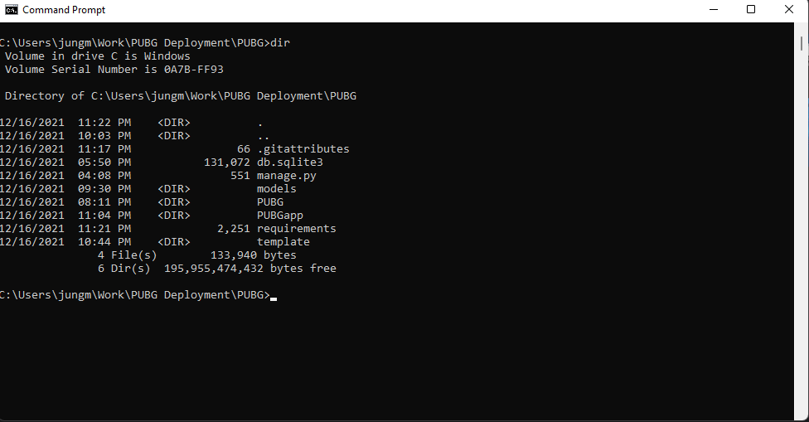
4. Use “python manage.py runserver” command to locally run the application on your webserver. Upon doing this use your IP address given in the command to access the application from the web browser of your choice.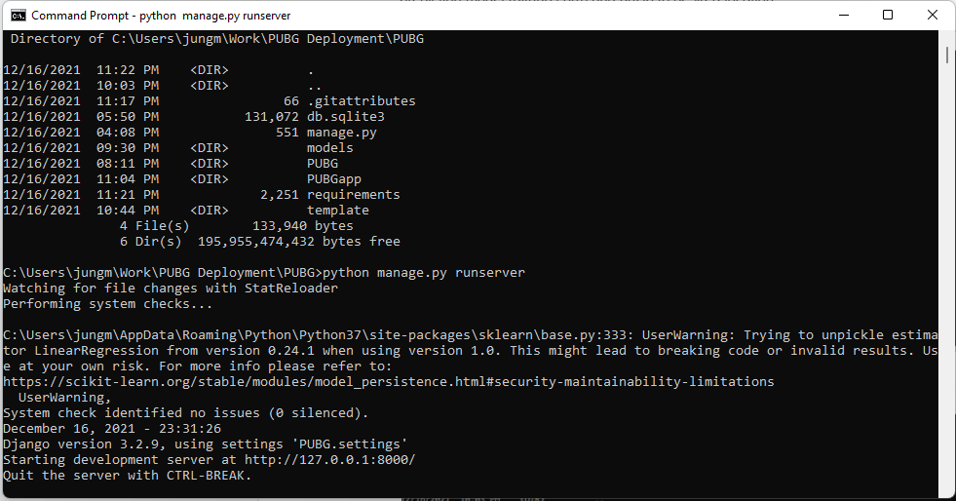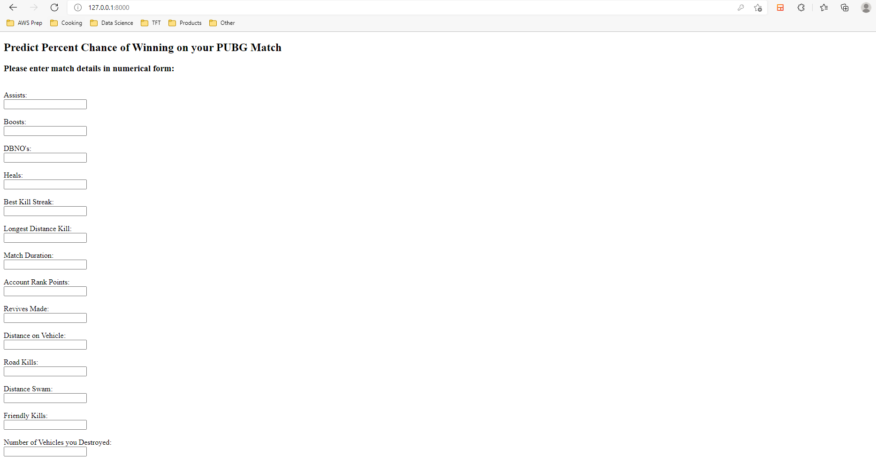
5. Upon reaching the webpage enter your game data into the given boxes and hit submit for you percent chance at getting a win in PUBG.